Getting started with Classification
As the name suggests, Classification is the task of “classifying things” into sub-categories. But, by a machine! If that doesn’t sound like much, imagine your computer being able to differentiate between you and a stranger. Between a potato and a tomato. Between an A grade and an F. Now, it sounds interesting now. In Machine Learning and Statistics, Classification is the problem of identifying to which of a set of categories (subpopulations), a new observation belongs, on the basis of a training set of data containing observations and whose categories membership is known.

Types of Classification
Classification is of two types:
- Binary Classification: When we have to categorize given data into 2 distinct classes. Example – On the basis of given health conditions of a person, we have to determine whether the person has a certain disease or not.
- Multiclass Classification: The number of classes is more than 2. For Example – On the basis of data about different species of flowers, we have to determine which specie our observation belongs.
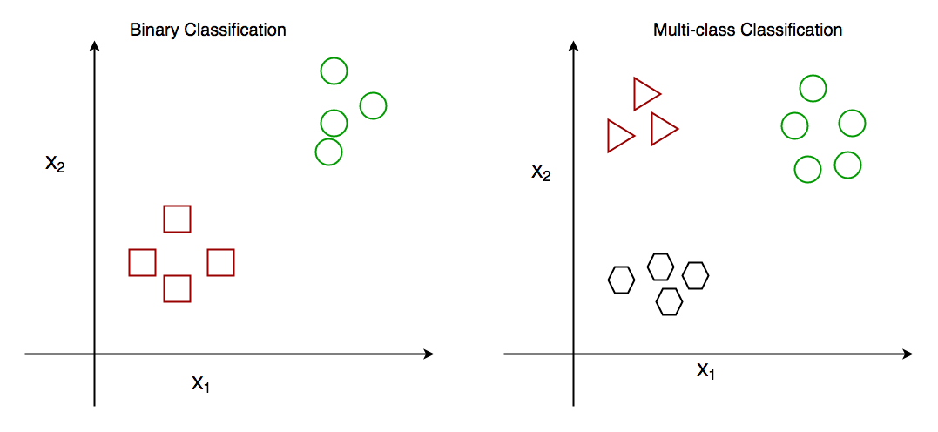
Fig: Binary and Multiclass Classification. Here x1 and x2 are the variables upon which the class is predicted.

How does classification works?
Suppose we have to predict whether a given patient has a certain disease or not, on the basis of 3 variables, called features.
This means there are two possible outcomes:
- The patient has the said disease. Basically, a result labeled “Yes” or “True”.
- The patient is disease-free. A result labeled “No” or “False”.
This is a binary classification problem.
We have a set of observations called the training data set, which comprises sample data with actual classification results. We train a model, called Classifier on this data set, and use that model to predict whether a certain patient will have the disease or not.
The outcome, thus now depends upon :
- How well these features are able to “map” to the outcome.
- The quality of our data set. By quality, I refer to statistical and Mathematical qualities.
- How well our Classifier generalizes this relationship between the features and the outcome.
- The values of the x1 and x2.
Following is the generalized block diagram of the classification task.
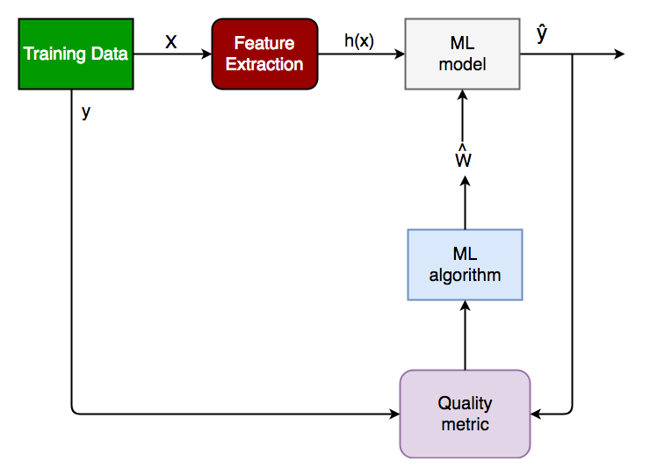
Generalized Classification Block Diagram.
- X: pre-classified data, in the form of an N*M matrix. N is the no. of observations and M is the number of features
- y: An N-d vector corresponding to predicted classes for each of the N observations.
- Feature Extraction: Extracting valuable information from input X using a series of transforms.
- ML Model: The “Classifier” we’ll train.
- y’: Labels predicted by the Classifier.
- Quality Metric: Metric used for measuring the performance of the model.
- ML Algorithm: The algorithm that is used to update weights w’, which updates the model and “learns” iteratively.
Types of Classifiers (algorithms)
There are various types of classifiers. Some of them are :
- Linear Classifiers: Logistic Regression
- Tree-Based Classifiers: Decision Tree Classifier
- Support Vector Machines
- Artificial Neural Networks
- Bayesian Regression
- Gaussian Naive Bayes Classifiers
- Stochastic Gradient Descent (SGD) Classifier
- Ensemble Methods: Random Forests, AdaBoost, Bagging Classifier, Voting Classifier, ExtraTrees Classifier
A detailed description of these methodologies is beyond an article!
Practical Applications of Classification
- Google’s self-driving car uses deep learning-enabled classification techniques which enables it to detect and classify obstacles.
- Spam E-mail filtering is one of the most widespread and well-recognized uses of Classification techniques.
- Detecting Health Problems, Facial Recognition, Speech Recognition, Object Detection, and Sentiment Analysis all use Classification at their core.

Implementation:
Let’s get a hands-on experience with how Classification works. We are going to study various Classifiers and see a rather simple analytical comparison of their performance on a well-known, standard data set, the Iris data set.
Requirements for running the given script:
- Python 3.8.10
- Scipy and Numpy
- Pandas for data i/o
- Scikit-learn Provides all the classifiers
Example

# Python program to perform classification on Iris dataset

# Run this program on your local Python interpreter
# provided you have installed the required libraries

# Importing the required libraries
import numpy as np
import pandas as pd
from sklearn.model_selection import train_test_split
from sklearn.metrics import accuracy_score
from sklearn import datasets
from sklearn import svm
from sklearn.tree import DecisionTreeClassifier
from sklearn.naive_bayes import GaussianNB

# import the iris dataset
iris = datasets.load_iris()
X = iris.data
y = iris.target

# splitting X and y into training and testing sets
X_train, X_test, y_train, y_test = train_test_split(
X, y, test_size=0.3, random_state=1)

# GAUSSIAN NAIVE BAYES
gnb = GaussianNB()
# train the model
gnb.fit(X_train, y_train)
# make predictions
gnb_pred = gnb.predict(X_test)
# print the accuracy
print("Accuracy of Gaussian Naive Bayes: ", accuracy_score(y_test, gnb_pred))

# DECISION TREE CLASSIFIER
dt = DecisionTreeClassifier(random_state=0)
# train the model
dt.fit(X_train, y_train)
# make predictions
dt_pred = dt.predict(X_test)
# print the accuracy
print("Accuracy of Decision Tree Classifier: ", accuracy_score(y_test, dt_pred))

# SUPPORT VECTOR MACHINE
svm_clf = svm.SVC(kernel='linear') # Linear Kernel
# train the model
svm_clf.fit(X_train, y_train)
# make predictions
svm_clf_pred = svm_clf.predict(X_test)
# print the accuracy
print("Accuracy of Support Vector Machine: ",
accuracy_score(y_test, svm_clf_pred))

Conclusion: Classification is a very vast field of study. Even though it comprises a small part of Machine Learning as a whole, it is one of the most important ones.
That’s all for now. In the next article, we will see how Classification works in practice and get our hands dirty with Python Code.

Basic Concept of Classification (Data Mining)
Data Mining: Data mining in general terms means mining or digging deep into data that is in different forms to gain patterns, and to gain knowledge on that pattern. In the process of data mining, large data sets are first sorted, then patterns are identified and relationships are established to perform data analysis and solve problems.

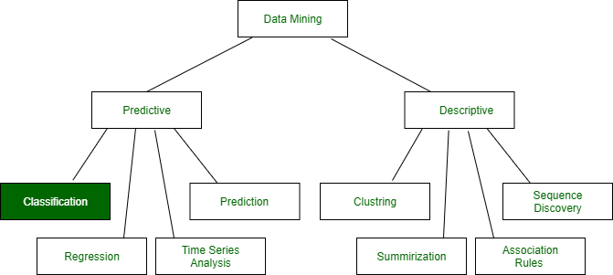
Classification: It is a data analysis task, i.e. the process of finding a model that describes and distinguishes data classes and concepts. Classification is the problem of identifying to which of a set of categories (subpopulations), a new observation belongs to, on the basis of a training set of data containing observations and whose categories membership is known.
Example: Before starting any project, we need to check its feasibility. In this case, a classifier is required to predict class labels such as ‘Safe’ and ‘Risky’ for adopting the Project and to further approve it. It is a two-step process such as :
- Learning Step (Training Phase): Construction of Classification Model
Different Algorithms are used to build a classifier by making the model learn using the training set available. The model has to be trained for the prediction of accurate results.
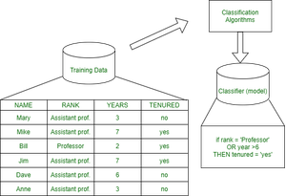
Test data are used to estimate the accuracy of the classification rule
- Classification Step: Model used to predict class labels and testing the constructed model on test data and hence estimate the accuracy of the classification rules.
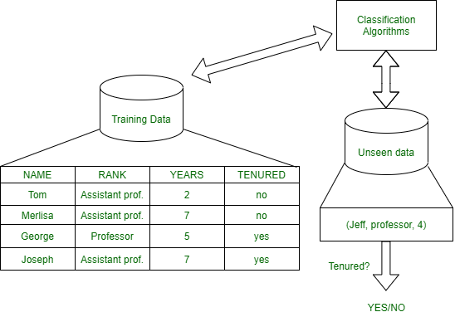
Test data are used to estimate the accuracy of the classification rule
Training and Testing:
Suppose there is a person who is sitting under a fan and the fan starts falling on him, he should get aside in order not to get hurt. So, this is his training part to move away. While Testing if the person sees any heavy object coming towards him or falling on him and moves aside then the system is tested positively and if the person does not move aside then the system is negatively tested.
Same is the case with the data, it should be trained in order to get the accurate and best results.
There are certain data types associated with data mining that actually tells us the format of the file (whether it is in text format or in numerical format).
Attributes – Represents different features of an object. Different types of attributes are:

- Binary: Possesses only two values i.e. True or False
Example: Suppose there is a survey evaluating some products. We need to check whether it’s useful or not. So, the Customer has to answer it in Yes or No.
Product usefulness: Yes / No
  - Symmetric: Both values are equally important in all aspects
  - Asymmetric: When both the values may not be important.
- Nominal: When more than two outcomes are possible. It is in Alphabet form rather than being in Integer form.
Example: One needs to choose some material but of different colors. So, the color might be Yellow, Green, Black, Red.
Different Colors: Red, Green, Black, Yellow
  - Ordinal: Values that must have some meaningful order.
Example: Suppose there are grade sheets of few students which might contain different grades as per their performance such as A, B, C, D
Grades: A, B, C, D
  - Continuous: May have an infinite number of values, it is in float type
Example: Measuring the weight of few Students in a sequence or orderly manner i.e. 50, 51, 52, 53
Weight: 50, 51, 52, 53
  - Discrete: Finite number of values.
Example: Marks of a Student in a few subjects: 65, 70, 75, 80, 90
Marks: 65, 70, 75, 80, 90
Syntax:
- Mathematical Notation: Classification is based on building a function taking input feature vector “X” and predicting its outcome “Y” (Qualitative response taking values in set C)
- Here Classifier (or model) is used which is a Supervised function, can be designed manually based on expert’s knowledge. It has been constructed to predict class labels (Example: Label – “Yes” or “No” for the approval of some event).
Classifiers can be categorized into two major types:
- Discriminative: It is a very basic classifier and determines just one class for each row of data. It tries to model just by depending on the observed data, depends heavily on the quality of data rather than on distributions.
Example: Logistic Regression
Acceptance of a student at a University (Test and Grades need to be considered)
Suppose there are few students and the Result of them are as follows :
- Generative: It models the distribution of individual classes and tries to learn the model that generates the data behind the scenes by estimating assumptions and distributions of the model. Used to predict the unseen data.
Example: Naive Bayes Classifier
Detecting Spam emails by looking at the previous data. Suppose 100 emails and that too divided in 1:4 i.e. Class A: 25%(Spam emails) and Class B: 75%(Non-Spam emails). Now if a user wants to check that if an email contains the word cheap, then that may be termed as Spam.
It seems to be that in Class A(i.e. in 25% of data), 20 out of 25 emails are spam and rest not.
And in Class B(i.e. in 75% of data), 70 out of 75 emails are not spam and rest are spam.
So, if the email contains the word cheap, what is the probability of it being spam ?? (= 80%)
Classifiers Of Machine Learning:
- Decision Trees
- Bayesian Classifiers
- Neural Networks
- K-Nearest Neighbour
- Support Vector Machines
- Linear Regression
- Logistic Regression
Associated Tools and Languages: Used to mine/ extract useful information from raw data.
- Main Languages used: R, SAS, Python, SQL
- Major Tools used: RapidMiner, Orange, KNIME, Spark, Weka
- Libraries used: Jupyter, NumPy, Matplotlib, Pandas, ScikitLearn, NLTK, TensorFlow, Seaborn, Basemap, etc.
Real–Life Examples :
- Market Basket Analysis:
It is a modeling technique that has been associated with frequent transactions of buying some combination of items.
Example: Amazon and many other Retailers use this technique. While viewing some products, certain suggestions for the commodities are shown that some people have bought in the past.
- Weather Forecasting:
Changing Patterns in weather conditions needs to be observed based on parameters such as temperature, humidity, wind direction. This keen observation also requires the use of previous records in order to predict it accurately.
Advantages:
- Mining Based Methods are cost-effective and efficient
- Helps in identifying criminal suspects
- Helps in predicting the risk of diseases
- Helps Banks and Financial Institutions to identify defaulters so that they may approve Cards, Loan, etc.
Disadvantages:
Privacy: When the data is either are chances that a company may give some information about their customers to other vendors or use this information for their profit.
Accuracy Problem: Selection of Accurate model must be there in order to get the best accuracy and result.
APPLICATIONS:
- Marketing and Retailing
- Manufacturing
- Telecommunication Industry
- Intrusion Detection
- Education System
- Fraud Detection
GIST OF DATA MINING :
- Choosing the correct classification method, like decision trees, Bayesian networks, or neural networks.
- Need a sample of data, where all class values are known. Then the data will be divided into two parts, a training set, and a test set.
Now, the training set is given to a learning algorithm, which derives a classifier. Then the classifier is tested with the test set, where all class values are hidden.
If the classifier classifies most cases in the test set correctly, it can be assumed that it works accurately also on the future data else it may be a wrong model chosen.

ML | Types of Regression Techniques
When Regression is chosen?
A regression problem is when the output variable is a real or continuous value, such as “salary” or “weight”. Many different models can be used, the simplest is linear regression. It tries to fit data with the best hyperplane which goes through the points.

Regression Analysis is a statistical process for estimating the relationships between the dependent variables or criterion variables and one or more independent variables or predictors. Regression analysis explains the changes in criteria in relation to changes in select predictors. The conditional expectation of the criteria is based on predictors where the average value of the dependent variables is given when the independent variables are changed. Three major uses for regression analysis are determining the strength of predictors, forecasting an effect, and trend forecasting.
Types of Regression:
- Linear regression is used for predictive analysis. Linear regression is a linear approach for modelling the relationship between the criterion or the scalar response and the multiple predictors or explanatory variables. Linear regression focuses on the conditional probability distribution of the response given the values of the predictors. For linear regression, there is a danger of overfitting. The formula for linear regression is: Y’ = bX + A.
- Polynomial regression is used for curvilinear data. Polynomial regression is fit with the method of least squares. The goal of regression analysis is to model the expected value of a dependent variable y in regards to the independent variable x. The equation for polynomial regression is: l = .
- Stepwise regression is used for fitting regression models with predictive models. It is carried out automatically. With each step, the variable is added or subtracted from the set of explanatory variables. The approaches for stepwise regression are forward selection, backward elimination, and bidirectional elimination. The formula for stepwise regression is .
- Ridge regression is a technique for analyzing multiple regression data. When multicollinearity occurs, least squares estimates are unbiased. A degree of bias is added to the regression estimates, and as a result, ridge regression reduces the standard errors. The formula for ridge regression is .
- Lasso regression is a regression analysis method that performs both variable selection and regularization. Lasso regression uses soft thresholding. Lasso regression selects only a subset of the provided covariates for use in the final model. Lasso regression is .
- ElasticNet regression is a regularized regression method that linearly combines the penalties of the lasso and ridge methods. ElasticNet regression is used for support vector machines, metric learning, and portfolio optimization. The penalty function is given by:.
Below is the simple implementation:

# importing libraries
import numpy as np
import matplotlib.pyplot as plt
from sklearn.linear_model import LinearRegression

x = 11 * np.random.random((10, 1))

# y = a * x + b
y = 1.0 * x + 3.0

# create a linear regression model
model = LinearRegression()
model.fit(x, y)

# predict y from the data where the x is predicted from the x
x_pred = np.linspace(0, 11, 100)
y_pred = model.predict(x_pred[:, np.newaxis])

# plot the results
plt.figure(figsize =(3, 5))
ax = plt.axes()
ax.scatter(x, y)

ax.plot(x_pred, y_pred)
ax.set_xlabel('predictors')
ax.set_ylabel('criterion')
ax.axis('tight')

plt.show()

Output:
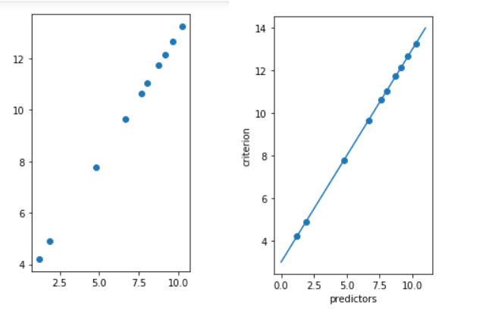

ML | Classification vs Regression
Prerequisite: Classification and Regression
the
Classification and Regression are two major prediction problems that are usually dealt with in Data mining and machine learning.

Classification is the process of finding or discovering a model or function which helps in separating the data into multiple categorical classes i.e. discrete values. In classification, data is categorized under different labels according to some parameters given in input and then the labels are predicted for the data.
The derived mapping function could be demonstrated in the form of “IF-THEN” rules. The classification process deal with the problems where the data can be divided into binary or multiple discrete labels.
Let’s take an example, suppose we want to predict the possibility of the winning of a match by Team A on the basis of some parameters recorded earlier. Then there would be two labels Yes and No.
Fig: Binary Classification and Multiclass Classification
Regression is the process of finding a model or function for distinguishing the data into continuous real values instead of using classes or discrete values. It can also identify the distribution movement depending on the historical data. Because a regression predictive model predicts a quantity, therefore, the skill of the model must be reported as an error in those predictions
Let’s take a similar example in regression also, where we are finding the possibility of rain in some particular regions with the help of some parameters recorded earlier. Then there is a probability associated with the rain.
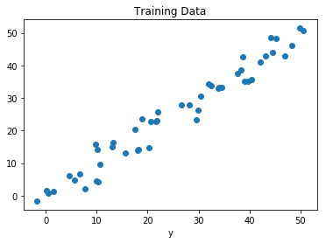
Fig: Regression of Day vs Rainfall (in mm)
Comparison between Classification and Regression:
Parameter | CLASSIFICATION | REGRESSION
Basic | The mapping function is used for mapping values to predefined classes. | Mapping Function is used for the mapping of values to continuous output.
Involves prediction of | Discrete values | Continuous values
Nature of the predicted data | Unordered | Ordered
Method of calculation | by measuring accuracy | by measurement of root mean square error
Example Algorithms | Decision tree, logistic regression, etc. | Regression tree (Random forest), Linear regression, etc.

ML | Types of Learning – Supervised Learning
Let us discuss what is learning for a machine is as shown below media as follows:

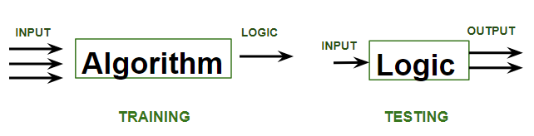
A machine is said to be learning from past Experiences(data feed-in) with respect to some class of tasks if its Performance in a given Task improves with the Experience. For example, assume that a machine has to predict whether a customer will buy a specific product let’s say “Antivirus” this year or not. The machine will do it by looking at the previous knowledge/past experiences i.e the data of products that the customer had bought every year and if he buys Antivirus every year, then there is a high probability that the customer is going to buy an antivirus this year as well. This is how machine learning works at the basic conceptual level.
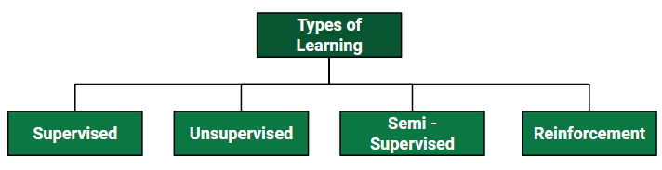
Supervised learning is when the model is getting trained on a labelled dataset. A labelled dataset is one that has both input and output parameters. In this type of learning both training and validation, datasets are labelled as shown in the figures below.
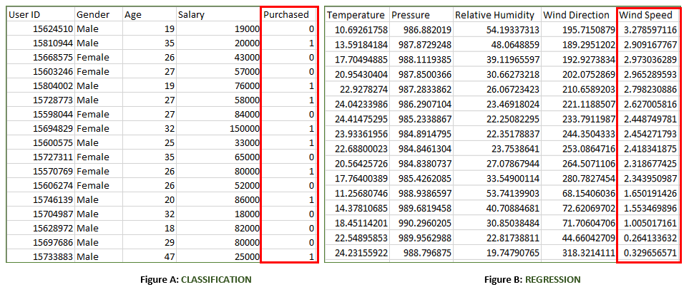
Both the above figures have labelled data set as follows:
- Figure A: It is a dataset of a shopping store that is useful in predicting whether a customer will purchase a particular product under consideration or not based on his/ her gender, age, and salary.
Input: Gender, Age, Salary
Output: Purchased i.e. 0 or 1; 1 means yes the customer will purchase and 0 means that the customer won’t purchase it.
- Figure B: It is a Meteorological dataset that serves the purpose of predicting wind speed based on different parameters.
Input: Dew Point, Temperature, Pressure, Relative Humidity, Wind Direction
Output: Wind Speed
Training the system: While training the model, data is usually split in the ratio of 80:20 i.e. 80% as training data and the rest as testing data. In training data, we feed input as well as output for 80% of data. The model learns from training data only. We use different machine learning algorithms(which we will discuss in detail in the next articles) to build our model. Learning means that the model will build some logic of its own.
Once the model is ready then it is good to be tested. At the time of testing, the input is fed from the remaining 20% of data that the model has never seen before, the model will predict some value and we will compare it with the actual output and calculate the accuracy.
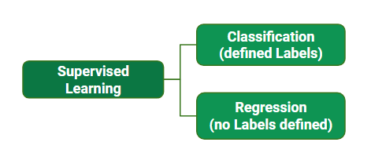

Types of Supervised Learning:
A. Classification: It is a Supervised Learning task where output is having defined labels(discrete value). For example in above Figure A, Output – Purchased has defined labels i.e. 0 or 1; 1 means the customer will purchase, and 0 means that the customer won’t purchase. The goal here is to predict discrete values belonging to a particular class and evaluate them on the basis of accuracy.
It can be either binary or multi-class classification. In binary classification, the model predicts either 0 or 1; yes or no but in the case of multi-class classification, the model predicts more than one class. Example: Gmail classifies mails in more than one class like social, promotions, updates, and forums.
B. Regression: It is a Supervised Learning task where output is having continuous value.
For example in above Figure B, Output – Wind Speed is not having any discrete value but is continuous in a particular range. The goal here is to predict a value as much closer to the actual output value as our model can and then evaluation is done by calculating the error value. The smaller the error the greater the accuracy of our regression model.
Example of Supervised Learning Algorithms:
- Linear Regression
- Logistic Regression
- Nearest Neighbor
- Gaussian Naive Bayes
- Decision Trees
- Support Vector Machine (SVM)
- Random Forest

Multiclass classification using scikit-learn
Multiclass classification is a popular problem in supervised machine learning.

Problem – Given a dataset of m training examples, each of which contains information in the form of various features and a label. Each label corresponds to a class, to which the training example belongs. In multiclass classification, we have a finite set of classes. Each training example also has n features.
For example, in the case of identification of different types of fruits, “Shape”, “Color”, “Radius” can be featured, and “Apple”, “Orange”, “Banana” can be different class labels.
In a multiclass classification, we train a classifier using our training data and use this classifier for classifying new examples.
Aim of this article – We will use different multiclass classification methods such as, KNN, Decision trees, SVM, etc. We will compare their accuracy on test data. We will perform all this with sci-kit learn (Python). For information on how to install and use sci-kit learn, visit http://scikit-learn.org/stable/
Approach –
- Load dataset from the source.
- Split the dataset into “training” and “test” data.
- Train Decision tree, SVM, and KNN classifiers on the training data.
- Use the above classifiers to predict labels for the test data.
- Measure accuracy and visualize classification.
Decision tree classifier – A decision tree classifier is a systematic approach for multiclass classification. It poses a set of questions to the dataset (related to its attributes/features). The decision tree classification algorithm can be visualized on a binary tree. On the root and each of the internal nodes, a question is posed and the data on that node is further split into separate records that have different characteristics. The leaves of the tree refer to the classes in which the dataset is split. In the following code snippet, we train a decision tree classifier in scikit-learn.

# importing necessary libraries
from sklearn import datasets
from sklearn.metrics import confusion_matrix
from sklearn.model_selection import train_test_split

# loading the iris dataset
iris = datasets.load_iris()

# X -> features, y -> label
X = iris.data
y = iris.target

# dividing X, y into train and test data
X_train, X_test, y_train, y_test = train_test_split(X, y, random_state = 0)

# training a DescisionTreeClassifier
from sklearn.tree import DecisionTreeClassifier
dtree_model = DecisionTreeClassifier(max_depth = 2).fit(X_train, y_train)
dtree_predictions = dtree_model.predict(X_test)

# creating a confusion matrix
cm = confusion_matrix(y_test, dtree_predictions)

SVM (Support vector machine) classifier –
SVM (Support vector machine) is an efficient classification method when the feature vector is high dimensional. In sci-kit learn, we can specify the kernel function (here, linear). To know more about kernel functions and SVM refer – Kernel function | sci-kit learn and SVM.

# importing necessary libraries
from sklearn import datasets
from sklearn.metrics import confusion_matrix
from sklearn.model_selection import train_test_split

# loading the iris dataset
iris = datasets.load_iris()

# X -> features, y -> label
X = iris.data
y = iris.target

# dividing X, y into train and test data
X_train, X_test, y_train, y_test = train_test_split(X, y, random_state = 0)

# training a linear SVM classifier
from sklearn.svm import SVC
svm_model_linear = SVC(kernel = 'linear', C = 1).fit(X_train, y_train)
svm_predictions = svm_model_linear.predict(X_test)

# model accuracy for X_test
accuracy = svm_model_linear.score(X_test, y_test)

# creating a confusion matrix
cm = confusion_matrix(y_test, svm_predictions)

KNN (k-nearest neighbors) classifier – KNN or k-nearest neighbors is the simplest classification algorithm. This classification algorithm does not depend on the structure of the data. Whenever a new example is encountered, its k nearest neighbors from the training data are examined. Distance between two examples can be the euclidean distance between their feature vectors. The majority class among the k nearest neighbors is taken to be the class for the encountered example.

# importing necessary libraries
from sklearn import datasets
from sklearn.metrics import confusion_matrix
from sklearn.model_selection import train_test_split

# loading the iris dataset
iris = datasets.load_iris()

# X -> features, y -> label
X = iris.data
y = iris.target

# dividing X, y into train and test data
X_train, X_test, y_train, y_test = train_test_split(X, y, random_state = 0)

# training a KNN classifier
from sklearn.neighbors import KNeighborsClassifier
knn = KNeighborsClassifier(n_neighbors = 7).fit(X_train, y_train)

# accuracy on X_test
accuracy = knn.score(X_test, y_test)
print accuracy

# creating a confusion matrix
knn_predictions = knn.predict(X_test)
cm = confusion_matrix(y_test, knn_predictions)

Naive Bayes classifier – Naive Bayes classification method is based on Bayes’ theorem. It is termed as ‘Naive’ because it assumes independence between every pair of features in the data. Let (x1, x2, …, xn) be a feature vector and y be the class label corresponding to this feature vector.
Applying Bayes’ theorem,
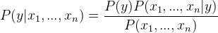
Since, x1, x2, …, xn are independent of each other,
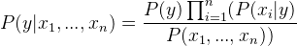
Inserting proportionality by removing the P(x1, …, xn) (since it is constant).
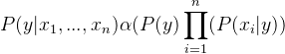
Therefore, the class label is decided by,
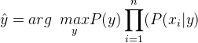
P(y) is the relative frequency of class label y in the training dataset.
In the case of the Gaussian Naive Bayes classifier, P(xi | y) is calculated as,
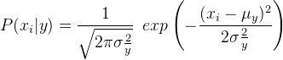

# importing necessary libraries
from sklearn import datasets
from sklearn.metrics import confusion_matrix
from sklearn.model_selection import train_test_split

# loading the iris dataset
iris = datasets.load_iris()

# X -> features, y -> label
X = iris.data
y = iris.target

# dividing X, y into train and test data
X_train, X_test, y_train, y_test = train_test_split(X, y, random_state = 0)

# training a Naive Bayes classifier
from sklearn.naive_bayes import GaussianNB
gnb = GaussianNB().fit(X_train, y_train)
gnb_predictions = gnb.predict(X_test)

# accuracy on X_test
accuracy = gnb.score(X_test, y_test)
print accuracy

# creating a confusion matrix
cm = confusion_matrix(y_test, gnb_predictions)

References –
- http://scikit-learn.org/stable/modules/naive_bayes.html
- https://en.wikipedia.org/wiki/Multiclass_classification
- http://scikit-learn.org/stable/documentation.html
- http://scikit-learn.org/stable/modules/tree.html
- http://scikit-learn.org/stable/modules/svm.html#svm-kernels
- https://www.analyticsvidhya.com/blog/2015/10/understaing-support-vector-machine-example-code/

